Analysis of a Trans Impedance Amplifier with Feedback
Thomas Dwyer and Phillip Hong
Abstract— In this experiment we were given the task to analyze a trans impedance amplifier. We specifically wanted to show how our feedback loop affected the overall gain, and bandwidth, of our circuit in two different scenarios; One, with an approximate current source, and the other, using an LED/ Photo diode combination to provide a current for our circuit. Our goal for this circuit was to design a trans impedance amplifier that exhibited an impedance of around 15kohms with a feedback resistance of 20kohms, and an impedance of 1.5kohms with a feedback resistance of 2kohms. In the end we achieved an impedance of around 16.8kohms using an FB resistor of 20kohms, and an impedance of 2.2kohms using an FB resistor of 2kohms; both well above our target specifications.

INTRODUCTION
T
ransimpedance amplifiers are often employed when voltages become too volatile to be taken as an input source. Such is the case when dealing with the LED/ Photo diode current source combination. In this case the current response is much more linear and well behaved than its voltage response. In other words, the trans impedance amplifier presents a low impedance to our current source, which keeps the photodiode voltage low, and allows the current to flow through the feedback resistance; determining our output voltage.
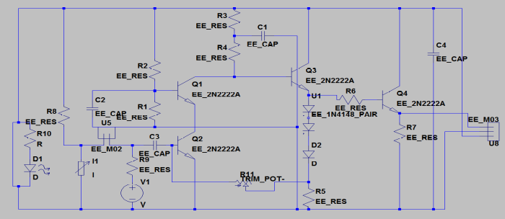
Fig. 1 Circuit schematic

In the case of our circuit we can see this action as follows: In either current source, we have set up our circuit in such a way that preserves a 0.7 base emitter voltage for Q1; this keeps the voltage across our current sources low, and because its sees a low voltage the current is easily drawn to the base of the transistor, which is equivalent to seeing a low impedance. Most of this current flows through the feedback resistor, as we have biased/ and selected our transistor to have a large input resistance. The current flows through the feedback resistor, and into the 500ohm resistor, determining our output voltage.

Experimental Procedure
After soldering everything onto our board, we are left with the equivalent circuit shown in figure one. From here we are tasked to find the frequency response of the current source, our voltage source in series with the 10kohm resistor, and the frequency response of the LED/ Photo diode current source. We do each in one of four scenarios: W/ FB @ 20kohm and 2kohm, and with a different voltage supply; 6V or 8V. We can show these setups on two circuits:
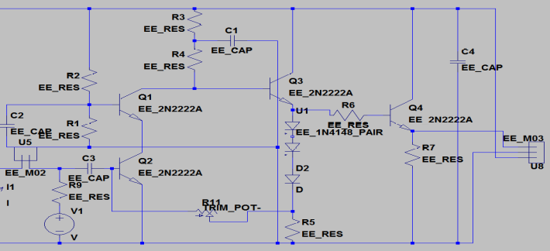
Fig 2. Current source

Disconnecting the LED/Photo diode gives us the circuit in Fig 2. Here we record 4 frequency responses. One with the feedback resistor at 20kohms and supply at 6V/ 8V, the other we measure with a feedback resistor at 2kohms and supply at 6V/8V. We make these measurements using an oscilloscope monitoring the voltage at the top pin of the header U8. We then multiply this ratio of our output voltage to the input voltage and multiply it by 10kohms to find the transimpedance of our circuit.
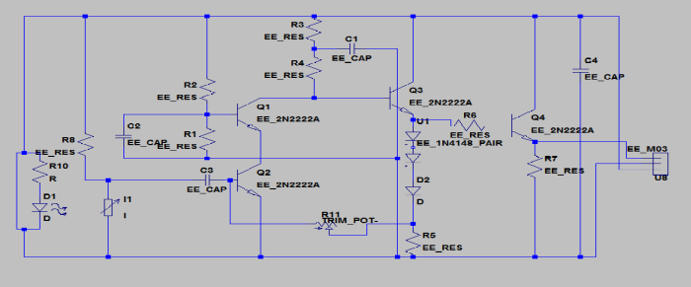
Fig 3. LED/ Photodiode current source

Disconnecting the current source gives us the circuit in Fig 3. Here we record 4 frequency responses, the method we used to find these responses is exactly the same as what we did using the current source, except that its sufficient to record the output voltage instead of multiplying the ratio by 10kohms. It is important to note that the left most side of our circuit is not connected to the main board, we are free to move it about, but we must remember that since the LED is a light source, varying the distance from the LED to the photo diode will affect the signal strength by the inverse square law.

Results
The schematic of our circuit is shown in figure one. It is important to note that we must disconnect our current source (voltage source in series with the 10kohm resistor) and connect U5 with a jumper to switch to the LED/ photodiode current source. Our layout of our circuit is shown as follows:
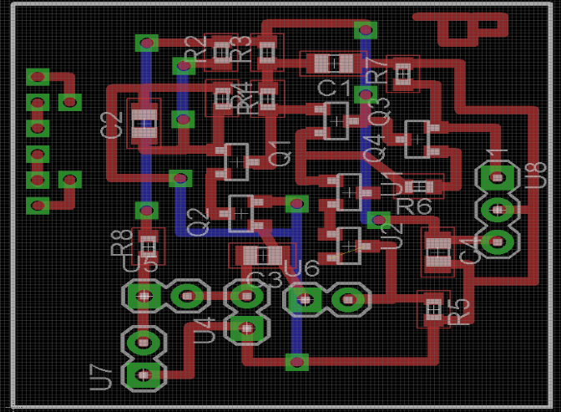
Fig 2. Layout of our circuit

Table 1. Current source FB 20kohm 6/8V supply
FB 20kohm 6V Supply FB 20kohm 8V supply
Freq(Hz) | DB(Vo/Vi)*10k | Freq(Hz) | DB(Vo/Vi)*10k
1.00E+03 | 7.96E+01 | 1.00E+03 | 79.04616
2.00E+03 | 8.24E+01 | 2.00E+03 | 82.2521
3.00E+03 | 8.30E+01 | 3.00E+03 | 83.16725
4.00E+03 | 8.41E+01 | 4.00E+03 | 83.16725
5.00E+03 | 8.41E+01 | 5.00E+03 | 83.54496
6.00E+03 | 8.41E+01 | 6.00E+03 | 83.54496
1.00E+04 | 8.42E+01 | 1.00E+04 | 83.63687
5.00E+04 | 8.45E+01 | 5.00E+04 | 83.9951
1.00E+05 | 8.45E+01 | 1.00E+05 | 84.33914
5.00E+05 | 8.44E+01 | 5.00E+05 | 84.33914
7.00E+05 | 8.43E+01 | 7.00E+05 | 84.0824
9.00E+05 | 8.43E+01 | 9.00E+05 | 84.0824
1.00E+06 | 8.43E+01 | 1.00E+06 | 83.51024
2.00E+06 | 8.39E+01 | 2.00E+06 | 82.77237
3.00E+06 | 8.25E+01 | 3.00E+06 | 81.58362
3.50E+06 | 8.17E+01 | 3.50E+06 | 80.47328
3.70E+06 | 8.15E+01 | 4.00E+06 | 79.93023
4.00E+06 | 8.10E+01 | 5.00E+06 | 78.73027
5.00E+06 | 7.98E+01 | 6.00E+06 | 77.14665
6.00E+06 | 7.87E+01 | 1.00E+07 | 73.62482
7.00E+06 | 7.81E+01
1.00E+07 | 7.61E+01
2.00E+07 | 7.01E+01

Midband Impedance, 16800 ohms 3db point @ 3.7MHz

Midband Impedance. 16480 ohms 3db point @ 3.0MHz

Table 2. Current source FB 2kohm 6/8V supply
FB 2kohm 6V FB 2kohm 8V
Freq(Hz) | DB(Vo/Vi)*10k | Freq(Hz) | DB(Vo/Vi)*10k
1.00E+03 | 65.66602 | 1.00E+03 | 66.36127
2.00E+03 | 67.00496 | 2.00E+03 | 67.60422
3.00E+03 | 67.00496 | 3.00E+03 | 68.69138
4.00E+03 | 67.00496 | 4.00E+03 | 67.00496
5.00E+03 | 67.60422 | 5.00E+03 | 67.00496
6.00E+03 | 67.60422 | 6.00E+03 | 66.36127
1.00E+04 | 67.60422 | 1.00E+04 | 66.36127
5.00E+04 | 68.69138 | 5.00E+04 | 70.52679
1.00E+05 | 68.69138 | 1.00E+05 | 69.65747
1.50E+05 | 65.66602 | 1.50E+05 | 68.69138
2.00E+05 | 67.00496 | 2.00E+05 | 68.69138
3.00E+05 | 67.00496 | 3.00E+05 | 67.00496
5.00E+05 | 66.36127 | 5.00E+05 | 67.00496
1.00E+06 | 66.84845 | 1.00E+06 | 67.60422
2.00E+06 | 67.00496 | 2.00E+06 | 64.91025
5.00E+06 | 64.91025 | 3.00E+06 | 64.91025
7.00E+06 | 65.66602 | 5.00E+06 | 67.60422
9.00E+06 | 65.66602 | 7.00E+06 | 67.00496
1.00E+07 | 65.66602 | 9.00E+06 | 65.66602
1.10E+07 | 65.66602 | 1.00E+07 | 66.36127
1.20E+07 | 67.00496 | 1.10E+07 | 65.66602
1.30E+07 | 65.66602 | 1.20E+07 | 63.04577
1.40E+07 | 63.16725 | 1.50E+07 | 60.98436
1.70E+07 | 62.1442 | 2.00E+07 | 58.0618
2.00E+07 | 58.0618

Approximate midband impedance 2200ohms, 3db point @17MHz

Approximate midband impedance 2400 ohms 3db point @ 12MHz

Table 3. LED/Photodiode Current source 20kohm 6/8Vsupply
FB 20kohm 6V FB 20kohm 8V
Freq(Hz) | DB(Vo)
1.00E+03 | -6.23E+00
1.00E+04 | -7.87E+00
1.50E+04 | -8.50E+00
2.00E+04 | -8.87E+00
2.50E+04 | -9.27E+00
3.00E+04 | -1.45E+01
3.50E+04 | -1.55E+01
Freq(Hz) | DB(Vo)
1.00E+03 | -6.0206
1.00E+04 | -7.33063
1.50E+04 | -8.17871
2.00E+04 | -8.87395
2.25E+04 | -8.99543
3.00E+04 | -10.1728
3.50E+04 | -12.3958
4.50E+04 | -15.391

3db point @24kHz

3db point @ 22.5kHz

Table 4. LED/Photodiode Current source 2kohm 6/8Vsupply
FB 2kohm 6V FB 2kohm 8V
Freq(Hz)  TABLE V  Theory vs. Experiment  . | DB(Vo) | Freq(Hz) | DB(Vo)
  Theory/LTSPICE | Experimental Values | Error
  $R_{sim}=$ 21.6kohm  (FB 20kohm 6V) | $R_{exp}=$ 16.80kohm | 22.2%
  $R_{sim}=$ 21.4kohm  (FB 20kohm 8V | $R_{exp}=$ 16.48kohm | 22.9%
  $R_{sim}=$ 2.43kohm  (FB 2kohm 6V) | $R_{exp}=$ 2.20kohm | 9.47%
  $R_{sim}=$ 2.42kohm  (FB 2kohm 6V | $R_{exp}=$ 2.40kohm | .827%
1.00E+03 | -1.36E+01 | 1.00E+03 | -1.34E+01
5.00E+03 | -1.40E+01 | 5.00E+03 | -1.39E+01
1.00E+04 | -1.42E+01 | 1.00E+04 | -1.41E+01
1.50E+04 | -1.45E+01 | 1.50E+04 | -1.44E+01
2.00E+04 | -1.47E+01 | 2.00E+04 | -1.48E+01
2.50E+04 | -1.50E+01 | 2.50E+04 | -1.51E+01
3.00E+04 | -1.55E+01 | 3.00E+04 | -1.54E+01
3.50E+04 | -1.60E+01 | 3.50E+04 | -1.57E+01
4.00E+04 | -1.65E+01 | 4.00E+04 | -1.61E+01
4.50E+04 | -1.67E+01 | 4.50E+04 | -1.64E+01
5.50E+04 | -1.73E+01 | 5.00E+04 | -1.66E+01
7.00E+04 | -1.81E+01 | 7.00E+04 | -1.73E+01
9.00E+04 | -1.90E+01 | 9.00E+04 | -1.80E+01
 |  | 1.00E+05 | -1.83E+01

3db point @ 45KHz

3db point @ 45kHz

References
- H. Babaie, “Experiment 4,” in 115B Lab Manuel, xth ed. City of Publisher, Country if not
- Hassan Babaie, (2014) ‘Week 8 : Experiment. EE115BL

This work is supported in part by the Electrical Engineering department of the University of California Los Angeles

